CURRICULUM VITAE
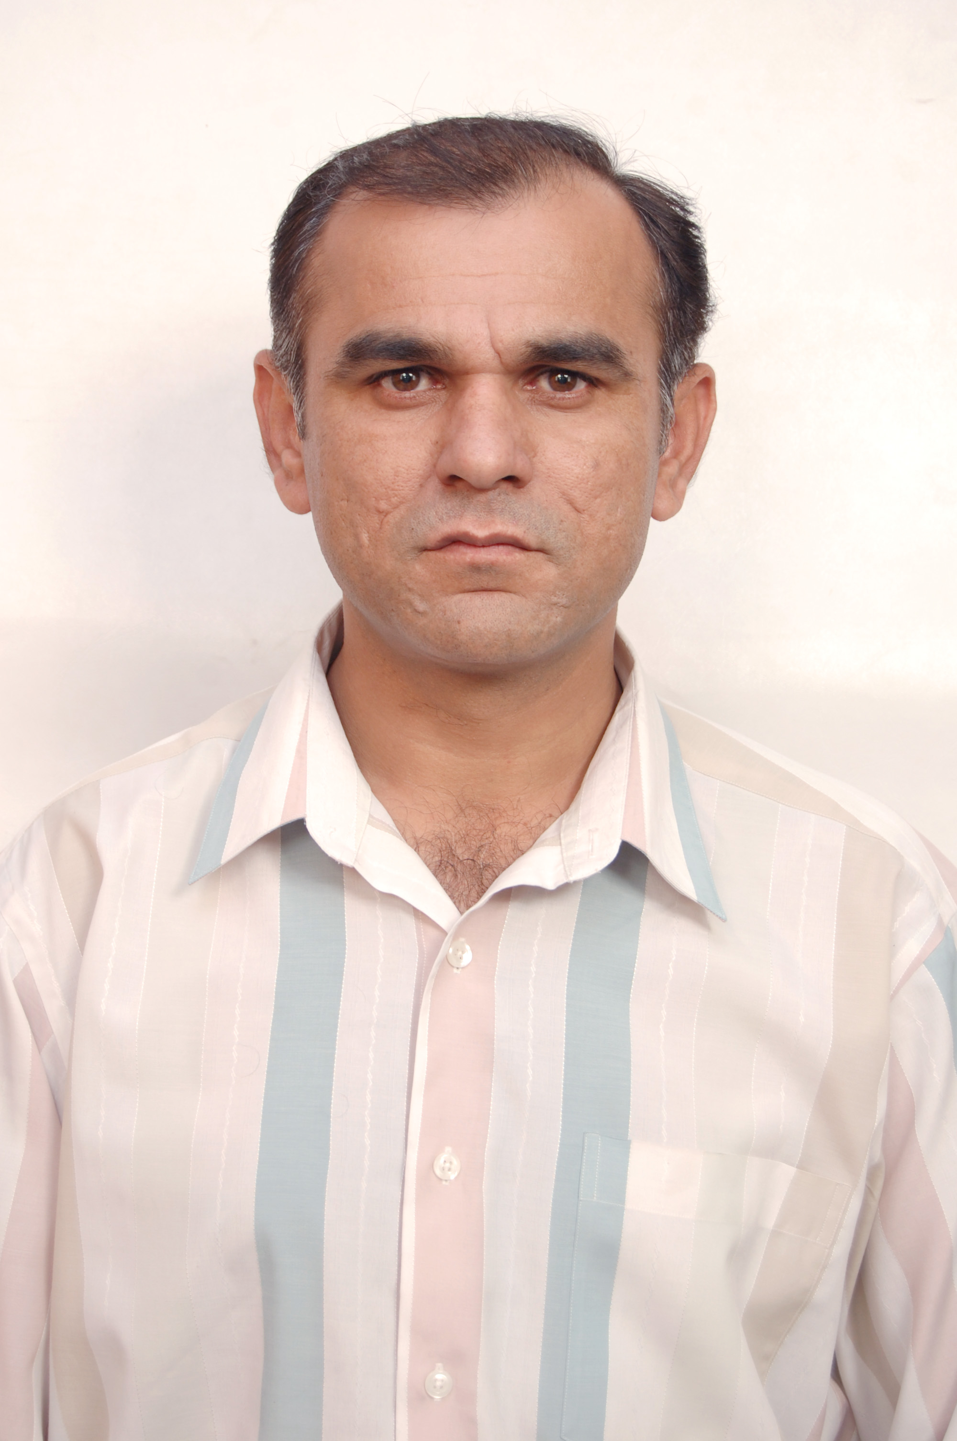
Personal Profile
Name: NAZAR IQBAL
Father’s Name: MALIK UMAR WADA
Country of Birth: Pakistan
& Residence
Date of Birth: 21-10-1974
Marital Status: MARRIED
Mailing Address: House No. 1320, Street No. 12, I-10/2, Islamabad
Ph # 0092-51-3335260646(mobile),
Email: nazariqbal@yahoo.com, nazariqbalmalik@gmail.com
Experience-Career History
- Director (2019 to-date) Federal Seed Certification & Registration Department
- Deputy Director (2016-19) Federal Seed Certification & Registration Department
- Seed Analyst (2005-2016) Federal Seed Certification & Registration Department
- Agriculture Officer (2004) Government of Punjab
Accomplishments
- Got accreditation status for CSTL from ISTA Switzerland. Have assessed 03 labs Expert
- Played role in up-dation of seed laws and introduction of PBR Act
- Successfully implemented 03 development project

On Job Trainings
- Seed Testing/Sampling training at Seed Testing Laboratory, Launceston, TASMANIA, AUSTRALIA (25TH November 2014-5th December 2014)
- Training/Workshop on Development of Business Planning organized by UNIDO from 15-16th March, 2011
- Seed Potato Technology, Certification, and Supply System from Wageningen University, the Netherlands (31st May to 26th June, 2010 (One Month)
- National Training Course on Vegetable Seed Health at Federal Seed Certification & Registration Department, Islamabad from 28th March 2007 to 1st April, 2007
- National Training Course on Laboratory Accreditation from Pakistan National Accreditation Council, Islamabad 25th March to 1st April, 2006

EDUCATION
Sr | Certificate | Institution | Year | Marks Obtained | Standing
1 | MSc (Hons.) Agricultural (Entomology)(2 years) | University of Arid Agriculture Rawalpindi | 1999-2001 | 3.14/4.00  (CGPA: Semester System) | (First Div.)
2 | BSc (Hons.) Agricultural (Entomology & Zoology) (4 years) | University of Arid Agriculture Rawalpindi | 1995-1999 | 3.68/4.00  (CGPA: Semester System) | (First Div.)
3 | Higher Secondary School Certificate (2 years) | Government College for Boys, D.G.Khan | 1995 | 777/1100 | (First Div.)
4 | Secondary School Certificate(10yrs) | Government Model High School, Jampur | 1991 | 597/850 | (First Div.)

REFERENCES
- Dr. Shakeel Ahmed Khan, Director General, Federal Seed Certification & Registration Department Islamabad. Ph. # 0092-51-9260126, Email: dg.fscrd@yahoo.com
- Dr. Akhlaq Hussain, Ex. Director General Federal Seed Certification & Registration Department Islamabad. Ph. No: 03325585819 Email: Akhlaq7@hotmail.com
- Dr. Muhammad Naeem, Chairman, Department of Entomology, University of Arid Agriculture, Rawalpindi (He has been supervisor of my research during MSc. Hons.)

