Curriculum Vitae

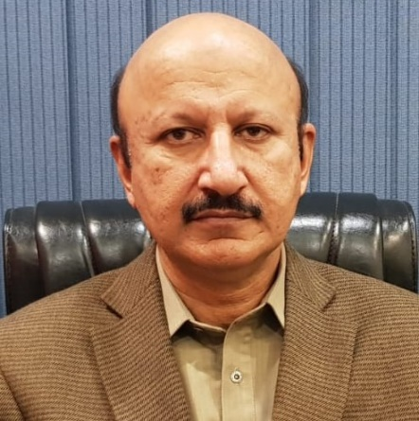
Name: Muhammad Azam Khan
Father Name: Muhammad Yousaf Khan
Date of Birth: 22-06-1966
CNIC No. 34502-6017108-9
Name of Organization: Federal Seed Certification & Registration Department
Date of Joining in FSC & RD: 28-04-1993
Training received in abroad: Seed Industry development in South Asian Countries, Hosted by Korea Seed and variety service in South Korea in 2014
Promoted as Deputy Director: 11-04-2016
Promoted as Director: 08-08-2019
Assume the Charge of Regional Director, Punjab: 24.10.2019
Remain Posted in Field Stations: Rahim Yar Khan, Khanewal, Vehari, Bhawalpur & Sakrand

